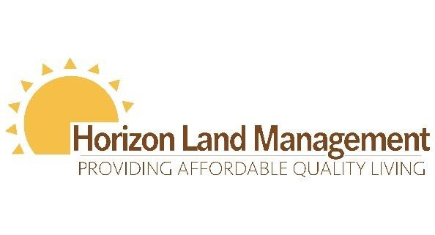
Having trouble paying your rent?
Often, we are faced with unforeseen circumstances during uncertain times and ever-changing current events.
Below is a list of agencies that may be able to help! There may be additional local agencies in your area, including your local churches that could be of assistance to you as well during your time of need.
Agency | Contact Number | Contact Email | Website
United Way | (330)263-6363 |  | www.uwwh.org/gethelp
Habitat For Humanity- Wayne County | (330)264-4999 |  | https://habitatwwc.org
Ohio Home Resource Fund | (888)995-4673
Salvation Army- Wooster | (330)264-4704 |  | neo.salvationarmy.org
Wayne Metro. Housing Authority | (330)264-2727
Ohio Department of Job and Family Service | (330)287-5800 or (877)612-5800 |  | www.waynecountydifs.com
We understand extenuating circumstances may exist on a case by case basis. We are happy to talk through these situations with you, and work to find the best resolution. However, you must reach out to the office immediately for any special considerations to be made.
Property: Oak Park
Manager: Christine Frady
Phone Number: (330)697-5835
Email: cfrady@horizonlm.com

