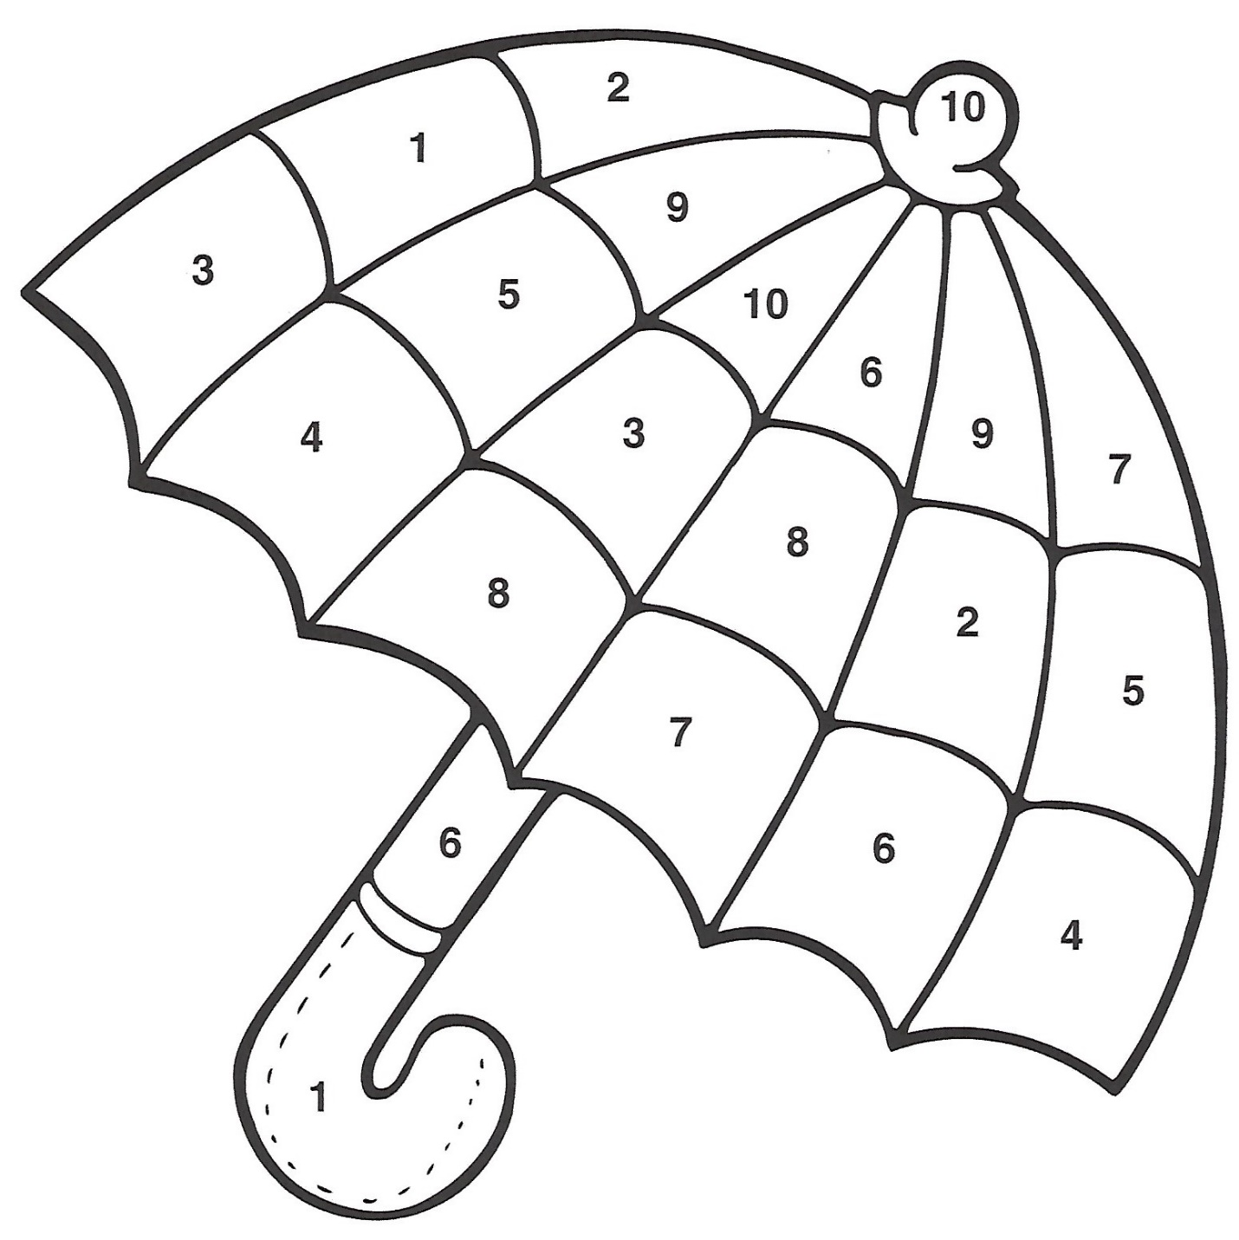

**Use the color key to color the umbrella**

**1 – red 4 – yellow 7 – purple**

**2 – green 5 – pink 8 – blue**

**3 – black 6 – orange 9 – grey**

**10 - brown**

Color by Number