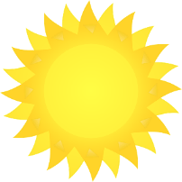
Spring Word Search
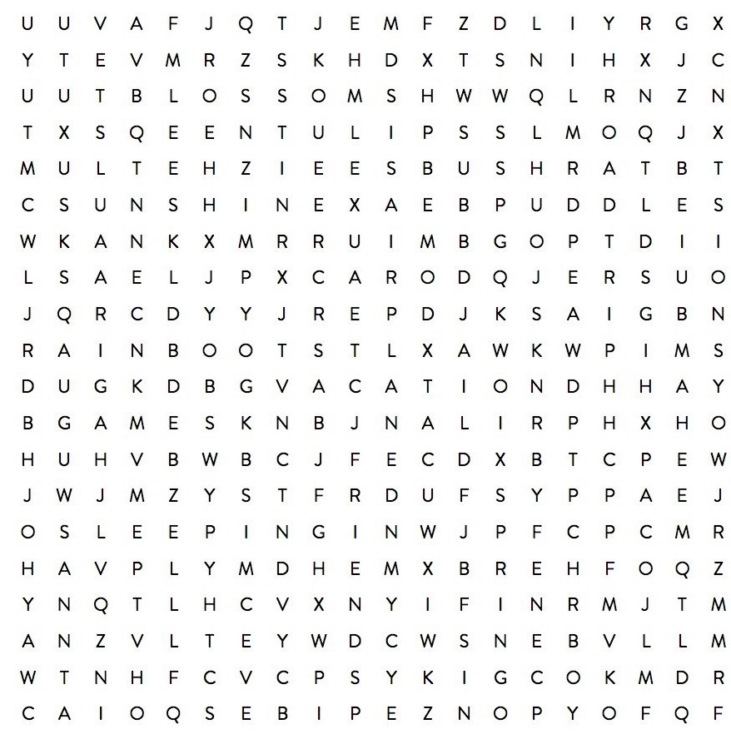

FRIENDS RAIN BOOTS TULIPS VACATION
ROAD TRIP SUNSHINE AIRPLANE BLOSSOMS
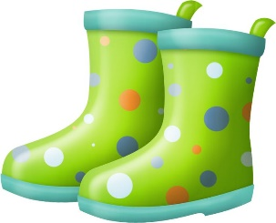
GAMES PUDDLES SLEEPING IN SPRING

