**SPRING MATCH UP**



B_MBL_ B_ _



R_ _NB_W



FL_W_RS



B_RD



S_NSH_N_

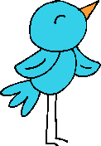

_MBR_LL_

Fill in the missing letters from each word, then match with the correct picture.